Wandering spleen in children: splenic loss is associated with delay rather than technique, and a reinforced two-pole splenopexy is described
Jun Shu¹, Jun Yang¹, Hongqiang Bian¹, Fei Peng¹, Ji Wang¹
¹ Department of General Surgery, Wuhan Children’s Hospital (Wuhan Maternal and Child Healthcare Hospital), Tongji Medical College, Huazhong University of Science & Technology, Wuhan 430016, Hubei, China
Corresponding author: Jun Yang, Department of General Surgery, Wuhan Children’s Hospital, Wuhan 430016, Hubei, China. E-mail: yjun201602@163.com
Abstract
Wandering spleen is a rare paediatric condition in which deficient suspensory ligaments permit splenic migration and pedicle torsion. We reviewed five children managed at a single centre between May 2015 and May 2026 (two girls, three boys; 2.75–13.08 years). Four had at least one earlier symptomatic episode that did not lead to splenic surgery: three were managed conservatively at parental request for a mean of 32 months, and one was treated as acute gastritis elsewhere one week before presentation. Four of the five ultimately lost the spleen — three to total splenectomy for infarction or necrosis, and one after an initial capsule-to-peritoneum splenopexy recurred within a month. Only the child treated with a reinforced two-pole fixation, in which full-thickness parenchymal sutures are buttressed with absorbable haemostatic gauze, retained a viable spleen. Splenic loss was associated with delay rather than with operative technique; a normal platelet count did not exclude necrosis.
Keywords Wandering spleen · Splenic torsion · Splenopexy · Splenectomy · Children
Introduction
Wandering spleen results from absent or deficient splenic suspensory ligaments, leaving the spleen mobile on a narrow vascular pedicle and vulnerable to torsion, infarction and injury to adjacent organs [1, 2]. It is rare in children, and the published experience consists largely of single cases and small series, so the relative contributions of diagnostic delay and of operative technique to splenic loss remain poorly defined [1, 12]. Splenic preservation is preferred whenever the parenchyma is viable, yet the reported splenopexy techniques — mesh wrapping, retroperitoneal pouch creation and simple capsular suture — each have recognised drawbacks, particularly in the enlarged spleen [1, 4, 5]. We report five consecutive children, four of whom lost the spleen, and describe a reinforced two-pole fixation devised after an earlier splenopexy failed.
Methods
We retrospectively reviewed all children with wandering spleen managed surgically at our institution between 1 May 2015 and 1 May 2026. Wandering spleen was defined as an abnormally mobile spleen displaced from its normal fossa on ultrasonography or computed tomography, with or without pedicle torsion. Demographic, clinical, laboratory, imaging, operative and follow-up data were extracted from the medical records. Follow-up was by outpatient review and telephone, with splenic position and perfusion assessed by ultrasonography or computed tomography (CT). Given the sample size, data are presented descriptively. The study was approved by the institutional ethics committee (2025R156-E01) and the requirement for informed consent was waived.
Results
Five children were identified (two girls, three boys), aged 2.75 to 13.08 years at first presentation and accounting for ten institutional encounters (Table 1). Abdominal pain, with or without vomiting or distension, was the presenting symptom in every case, and ultrasonography or CT established the diagnosis before operation in all five.
Four children had at least one earlier symptomatic episode that did not lead to splenic surgery. In Cases 1 to 3 the families declined the operation advised at first presentation and elected conservative management; all three were re-admitted with recurrent pain and came to splenic surgery after a mean of 32 months. Case 5 had been admitted to another hospital one week earlier and treated as acute gastritis.
Four of the five ultimately lost the spleen. Cases 1 and 2 developed pedicle torsion with infarction and underwent total splenectomy. Case 5, a boy of 13 years presenting 18 hours after the onset of pain, had a whirl sign on non-contrast CT; at laparotomy the pedicle was twisted through 720°, the parenchyma failed to reperfuse after detorsion, and total splenectomy with splenic artery ligation was performed; he remains well 5 months later. Case 3 underwent laparoscopic partial splenectomy with splenopexy for partial infarction; because the enlarged spleen (17.3 × 7.6 cm) could not be accommodated within a subperitoneal pouch, the poles were secured to the diaphragm and lateral peritoneum with 5-0 silk reinforced with Hem-o-lok clips. The spleen recurred within one month and was removed with omental autotransplantation.
Case 4, a boy of 2 years and 9 months, presented with gastric volvulus and antral perforation complicating wandering spleen. After repair of the perforation the viable spleen was repositioned and fixed by the reinforced two-pole technique (Fig. 1). Absorbable haemostatic gauze was laid on the visceral and diaphragmatic surfaces of the upper pole, and a 2-0 non-absorbable silk suture was passed through the gauze and the full thickness of the parenchyma, through the diaphragmatic muscle, and back through the parenchyma to be tied on the visceral side; the lower pole was secured to the lateral abdominal wall in the same way. He remains asymptomatic with a normally sited spleen at 13 months.
All four children who underwent total splenectomy developed postoperative thrombocytosis, peaking at 918 × 10⁹/L in Case 5, which normalised on oral dipyridamole. None developed overwhelming post-splenectomy infection, thromboembolism or pulmonary hypertension. Preoperative thrombocytosis preceded splenectomy in Cases 1 and 2, and platelet counts were normal at every encounter in which the spleen remained viable; Case 5, however, had established necrosis with a normal preoperative platelet count.
Discussion
In this series splenic loss was associated with the interval between the first symptomatic episode and definitive surgery, not with the operative technique. Three families declined the operation initially recommended and returned a mean of 32 months later, by which time infarction had occurred in two of them; a fourth child was labelled as having acute gastritis elsewhere and lost the spleen a week afterwards. Wandering spleen has been called the great pretender for precisely this reason [6], and our experience supports operating at the time of diagnosis, including in the asymptomatic child, rather than observing [3].
The corollary is that a normal platelet count is not reassuring. Reactive thrombocytosis has been proposed as a preoperative marker of splenic infarction [7], and our first two cases fit that pattern. Case 5 did not: the spleen was necrotic after only 18 hours of symptoms, before any reactive rise could develop. Thrombocytosis therefore appears to reflect a period of functional asplenia of sufficient duration rather than infarction itself, and it should not be used to exclude necrosis in a child with suspected torsion. In the acute setting the whirl sign, which established the diagnosis on non-contrast CT in Case 5, is the more useful sign.
Splenopexy techniques are numerous and none is universally applicable. Mesh wrapping is effective but may be impracticable in the enlarged spleen and carries risks of infection and foreign-body reaction [4, 8]. Retroperitoneal pouch fixation is well described but depends on creating a pocket large enough to accept the spleen, and compression within the pouch has been reported to cause ischaemia; when the spleen is very large the pouch cannot be formed, and some authors have proceeded to splenectomy. That is what happened in Case 3, in whom the pouch was abandoned and the capsule sutured superficially, with failure within a month.
The reinforced two-pole technique was devised in response to that failure. Passing the suture through the full thickness of the parenchyma rather than the capsule alone provides fixation that does not depend on capsular integrity, while the haemostatic gauze distributes the load, limits suture cut-through and encourages local adhesion. It requires no prosthetic material and no retroperitoneal dissection, and, unlike mesh or pouch fixation, does not depend on the spleen fitting within a wrap or pocket - a property that should in principle extend to the enlarged spleen, although this remains untested (see below). A comparable rationale underlies the sutureless button-and-hole method, which likewise avoids reliance on the capsule alone [9]. Associated anomalies should also be sought, since wandering spleen may coexist with gastric volvulus, as in Case 4, and with torsion of the pancreatic tail [10, 11].
These observations must be read against two limitations. First, the association between delay and splenic loss is descriptive rather than causal: the cohort comprised only children who ultimately underwent splenic surgery, excluding any diagnosed but never operated on, and with five patients and no statistical comparison, confounding cannot be excluded. Second, the technique was used in one patient followed for 13 months, and this is a preliminary technical description rather than a validated standard. The series is small, retrospective and single-centre, and the child in whom the technique succeeded had a spleen of normal size (8.4 × 3.7 cm), whereas the giant spleen of Case 3 is precisely the circumstance in which fixation is most demanding; whether the technique holds in that setting is untested. Multicentre collection with longer follow-up is required.
Conclusion
In children with wandering spleen, splenic loss was more often associated with delay than with any deficiency of operative technique, and splenopexy should be undertaken when the diagnosis is made. A normal platelet count does not exclude necrosis. Reinforced full-thickness two-pole fixation buttressed with haemostatic gauze is a simple option after a failed splenopexy, but it requires further evaluation.
Table 1
Clinical course and outcome of the five children with wandering spleen. CT computed tomography, F female, M male, PC platelet count
Case | Sex, age at first presentation | Course before definitive splenic surgery | Findings at definitive operation | Operation | Outcome
1 | M, 3.75 years | Abdominal pain; operation advised but declined; conservative treatment for 5 days; re-admitted and operated 16 months later | CT: pedicle torsion with splenic infarction. PC 428 ×10⁹/L (elevated) | Laparotomy; total splenectomy | Spleen lost
2 | F, 5.5 years | Abdominal pain; operation advised but declined; conservative treatment for 7 days; re-admitted and operated 19 months later | CT: pedicle torsion with splenic infarction. PC 525 ×10⁹/L (elevated) | Laparoscopy converted to laparotomy; total splenectomy | Spleen lost
3 | F, 4.5 years | Abdominal pain and vomiting; two episodes managed conservatively at parental request; operated 62 months after first presentation | CT: partial infarction; spleen 17.3 × 7.6 cm. PC 172 ×10⁹/L (normal) | Laparoscopic partial splenectomy with splenopexy; recurrence at 1 month; total splenectomy with omental autotransplantation | Spleen lost
4 | M, 2.75 years | Abdominal distension for 2 hours; first presentation, operated the same admission | CT: pedicle torsion, gastric volvulus, gastric perforation; spleen 8.4 × 3.7 cm. PC 177 ×10⁹/L (normal) | Laparotomy; repair of gastric perforation and reinforced two-pole splenopexy | Spleen preserved; well at 13 months
5 | M, 13.08 years | Abdominal pain for 18 hours; an episode one week earlier had been managed as acute gastritis at another hospital | CT: whirl sign, splenic necrosis; pedicle torsion 720° at operation. PC normal | Laparotomy; total splenectomy with splenic artery ligation | Spleen lost; well at 5 months
Figure 1
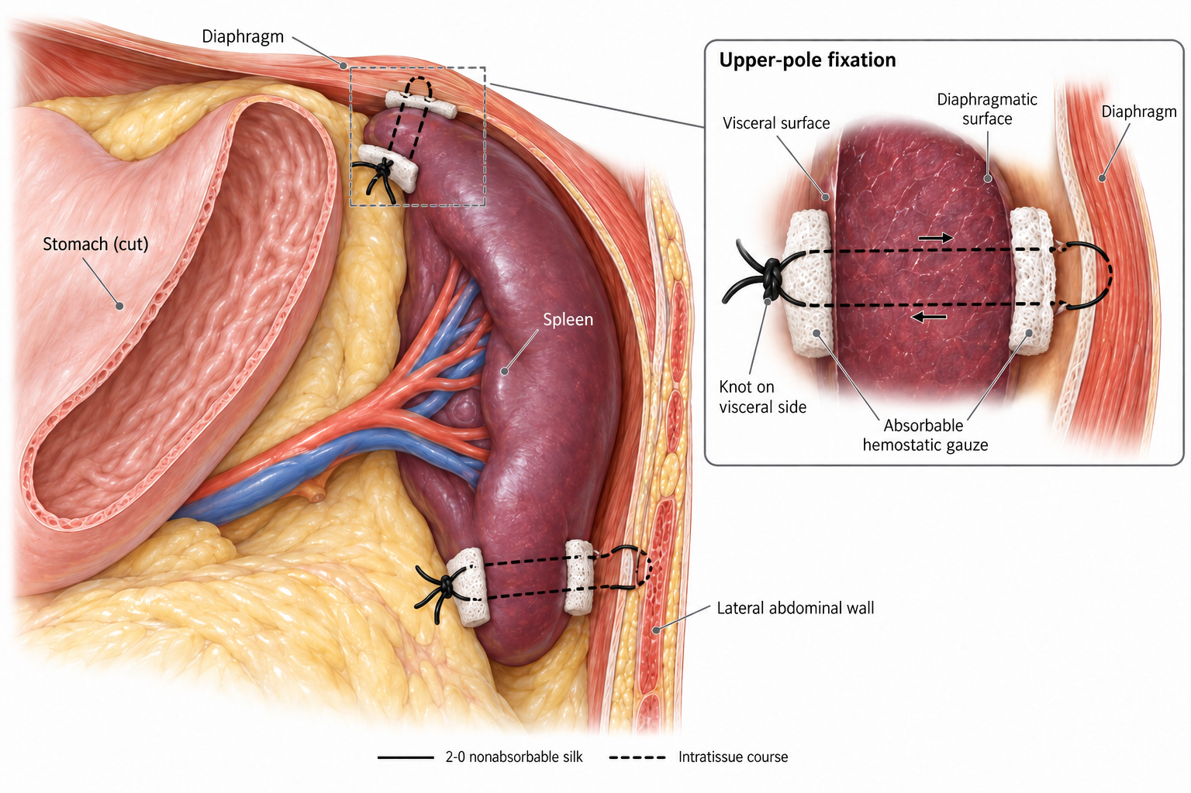
Fig. 1 Reinforced two-pole splenopexy. Absorbable haemostatic gauze is applied to the visceral and diaphragmatic surfaces of the splenic pole; a 2-0 non-absorbable silk suture is passed through the gauze and the full thickness of the parenchyma, through the diaphragmatic muscle, and back through the parenchyma, and is tied on the visceral surface. The lower pole is secured to the lateral abdominal wall in the same way. Inset: detail of upper-pole fixation.
Declarations
Author contributions Jun Shu conceived the study, acquired and interpreted the data and prepared the manuscript. Fei Peng and Ji Wang drafted the manuscript. Jun Yang and Hongqiang Bian revised the manuscript critically. All authors approved the final version.
Funding No funding was received for this work.
Data availability The datasets generated and analysed during the current study are available from the corresponding author on reasonable request.
Ethics approval This study was approved by the Ethics Committee of Wuhan Children’s Hospital (Wuhan Maternal and Child Healthcare Hospital), Tongji Medical College, Huazhong University of Science & Technology (2025R156-E01).
Consent to participate Given the retrospective nature of the study, the requirement for informed consent was waived by the ethics committee. No identifiable information is included.
Competing interests The authors declare no competing interests.
References
1. Ganarin A, Fascetti Leon F, La Pergola E, Gamba P (2021) Surgical approach of wandering spleen in infants and children: a systematic review. J Laparoendosc Adv Surg Tech A 31:468–477
2. Cui Q, Xu X, Li C, Tang L (2024) Wandering spleen combined with pedicle torsion and splenic infarction: a rare case report and literature review. Front Pediatr 12:1429490
3. Fiquet-Francois C, Belouadah M, Ludot H, Defauw B, Mcheik JN, Bonnet JP et al (2010) Wandering spleen in children: multicenter retrospective study. J Pediatr Surg 45:1519–1524
4. Torri F, Parolini F, Vanzetti E, Milianti S, Cheli M, Alberti D (2015) Urgent laparoscopic mesh splenopexy for torsion of wandering spleen and distal pancreas: a case report. Asian J Endosc Surg 8:350–353
5. Alqadi GO, Saxena AK (2019) Is laparoscopic approach for wandering spleen in children an option? J Minim Access Surg 15:93–97
6. Radillo L, Taddio A, Ghirardo S, Bramuzzo M, Pederiva F, Maschio M et al (2016) The great pretender: pediatric wandering spleen: two case reports and review of the literature. Pediatr Emerg Care 32:619–622
7. Wang Z, Peng C, Wu D, Wang K, Chen Y (2022) Diagnosis and treatment of splenic torsion in children: preoperative thrombocytosis predicts splenic infarction. BMC Pediatr 22:440
8. Cohen O, Baazov A, Samuk I, Schwarz M, Kravarusic D, Freud E (2018) Emergencies in the treatment of wandering spleen. Isr Med Assoc J 20:354–357
9. Zivkovic SM (1998) Sutureless “button and hole” splenopexy. Pediatr Surg Int 13:220–222
10. Okazaki T, Ohata R, Miyano G, Lane GJ, Takahashi T, Yamataka A (2010) Laparoscopic splenopexy and gastropexy for wandering spleen associated with gastric volvulus. Pediatr Surg Int 26:1053–1055
11. Colombo F, D’Amore P, Crespi M, Sampietro G, Foschi D (2019) Torsion of wandering spleen involving the pancreatic tail. Ann Med Surg (Lond) 50:10–13
12. Al Blooshi M, Aboelkheir A, Hiremath A, Jaber G, AlMarzouqi M (2025) The enigmatic wandering spleen: managing three cases in a tertiary setting. BMC Pediatr 25:631

